Rosanna Cub Scouts
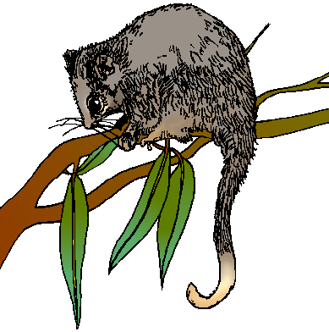
Activity: Possum Prowl
When: 17th June, 2008

Start Time: Arrive 6:45pm – need to make arrangements and tour starts at 7 sharp

Finish Time: 8.30pm

Cost: $7 each.

Where: La Trobe University
Wildlife Reserve

Meet at: Wildlife Reserve Office – enter from LaTrobe Ave (between Main Dve and Ring Rd – Melway 19 G5)

What to wear: Cub Uniform
Solid Footwear
Dress for warmth and bring a coat if necessary.
No torch – Adults only (don’t want to affect night vision)

What we will see: Good Question! It depends on two things.
1. How noisy you are!
2. The Weather

However a ranger will take us on a guided tour, so hopefully we will see something.

Facilities: There is a shelter. If the Weather turns bad, we will go for a quick walk and then retire to the shelter. If steady rain prior, contact Akela on 0411 121 495 to see if it’s still on.

WE NEED TO KNOW NUMBERS AS BEST WE CAN… PLEASE ADVISE AKELA HOW MANY YOU WILL HAVE ATTENDING ASAP ON:
9434 7594 OR akela@rosannacubs.org

NOTE: that we have a cap of 30 people…. Unfortunately we can’t take any more on the tour.

